Observation of the Sun Through Modern and Ancient Eyes

------Project 1

Author’s name: Zongyi, Huang SID：105925503

Nienfu, Hsieh SID：107016702

Lingyin Lu SID：106992297

**Background**

From ancient view, people such as Mayan use variable equipment to evaluate time. Nowadays people can use more scientific methods to evaluate time more accurately. To evaluate time, calculation by calculus is also a good method.

**Introduction**

In this report, we are going to describe our mathematical method, calculation and thought about the project 1 of Calculus 3, which topic is “Observations of the Sun Through Modern and Ancient Eyes”. We used the given equations about earth, observe the angle of incidence to calculate and evaluate the phenomenon of changes of day and night.

**Observation from three different latitudes**

In this part, we use the equation about earth which related to sun, to find the relationship of day an night from different latitudes: Boulder, Chichen Itza, and Maxico.

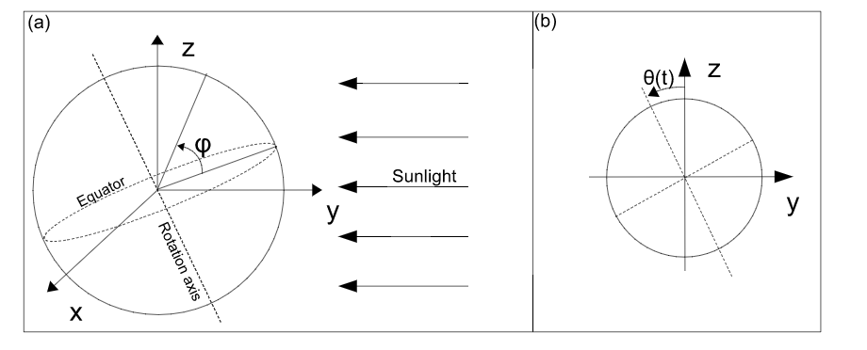

x(t, φ) = cos(φ) sin(2πt)

y(t, φ) = − cos(φ) cos(2πt) cos(Θ(t)) + sin(φ) sin(Θ(t)) (2)

z(t, φ) = cos(φ) cos(2πt) sin(Θ(t)) + sin(φ) cos(Θ(t)),

Θ(t) = −0.41 cos(2πt / 365.25) ----------given function

The variable φ is represent the latitude of place in earth, for example, Boulder is N 40.0°. We did the relationship between day and night for 3 different location to find the relationship between sun and earth during a year,

Graph 1

The graph of relationship between day and night (0<t<5, calculation on Mathematica)

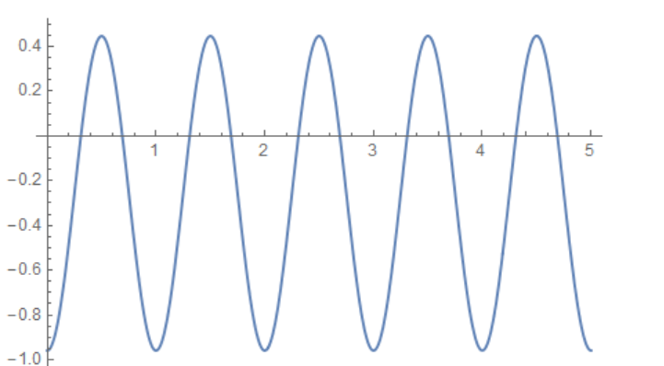

From this graph, we can see in first five days, the average time of day light is less than that at night. We assumed this happened on winter which is consist with the common sense we learned.

Graph 2

(290>t>205). Calculation on Mathematica.

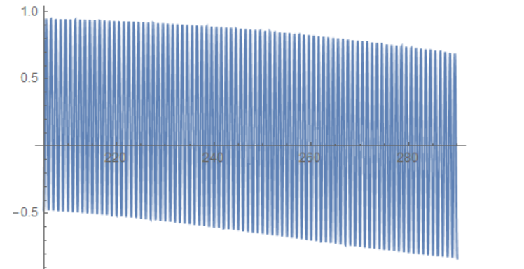

From this graph, we can see the whole function tend to decrease by during of time. Because the range of value t is reversed (t between 290 and 205), in fact, we can see that the time of day light is decreasing by increasing of days. We gauss the range of these days are between summer solstice and winter solstice.

Graph 3

(0<t<365). Calculation on Mathematica.

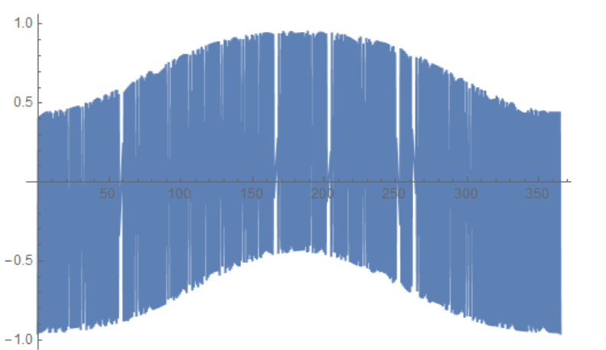

From this graph, t is in the range of 365 days, which is for a year. We can see that the day light (Variable maximum value) increases and then decrease, opposite for the time on night (Variable minimum value). We gauss that this graph conforms the whole year of days on earth, that winter solstice has least time on day light and summer solstice has most time on night.

There are two solstices in a year, one is in the summer and winter. According to our calculating, the summer solstice occurs at t = 182, and the winter solstice occurs at t = 0. The equinoxes happen twice a year too, one occurs at t = 91 and another one occurs at t=273.

Calculations and our thought

To find the day which have the most time of day light, first we gauss the range of time which can happen this phenomenon. In addition, by comparing Graph 3:

We found that the day which have the most day time is at the medium of the function (around 182th days).

We pick different values of time t to test which day has most day time. In Mathematica, we did variable numbers (t= 170, 180, 181, 182, 183, 185, 190).

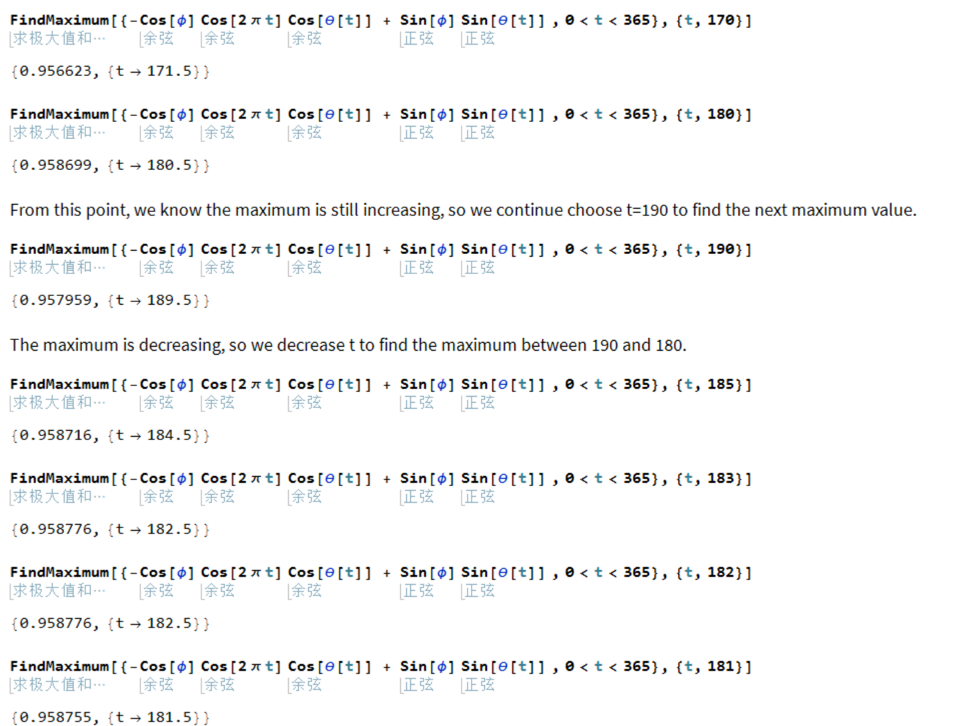

From calculation, we found that the day which have most day time is between 182th day and 183th day, which we consider as summer solstice.

To find day which have most time on night, we use the same thought above that we related it to common sense and graph 3. We found that the day should be around when t = 0 and t = 365. We considered that when time t is greater than 365, a new cycle will happen.

We used same method to find the day with most night time and we found it is on between t = 0 and t = 1, which we gauss it happens on the first day of a year. (Calculation on Mathematica).

To find days which have same day time and night time, we use the same way to evaluate and calculate the time. We found it conformed when t = 91 and 273. (Calculation on Mathematica). We consider when time t = 91, it represents the day of spring equinox. When time t = 91, it represents the day of fall equinox.

At the date of equinoxes, the daylight time are equal to night time. Therefore, we think it is appropriate to call the date equinox.

For the other two place, we get another two graphs.

The first graph shows the daylight time and night time for Chichen Itza.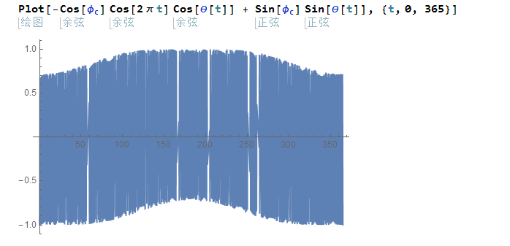

The second graph shows the daylight time and night time for the South Pole

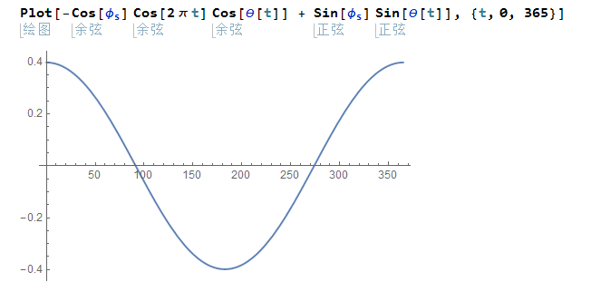

As we can see, latitude does effect the season and the length of a day. In the South Pole, which has the highest latitude, half of a year is all daylight, and the other half time is all night time. If we want to catch some sun, the best time is from t = 273 to the second year at t = 91.In the Chichen Itza, which has lower latitude than Boulder, the daylight time of a day is much longer than Boulder due to it is close to equator. However, the latitude does not influence seasons. Season of a place is depend on which hemisphere it locate.

There is only one sun rising and setting happen in a year in South Pole, the sun is rising at fall equinox, and it is setting at spring equinox. In the time after spring equinox and before fall equinox, the south pole is night, and other time is daytime.

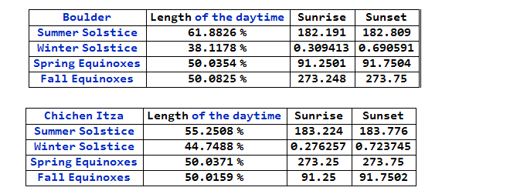

By comparing all graphs we have, we can predict that the city locate at S 40° has opposite season with Boulder, for example, the longest daylight time occur at t=180 in Boulder, but the day is the longest night time of this city.

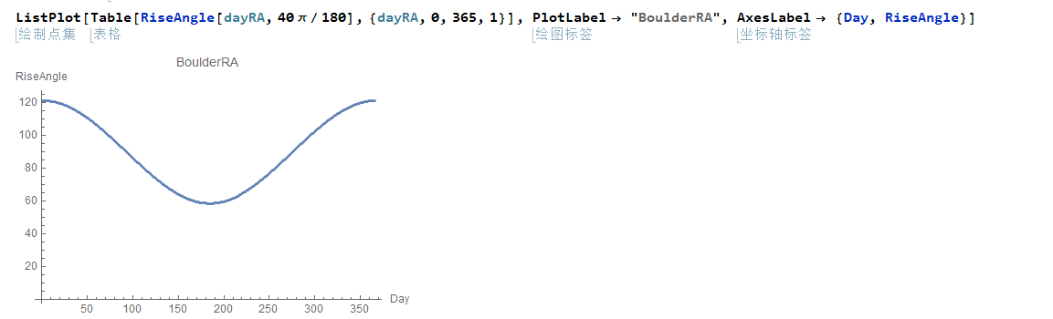

This graph shows us the rising angle in Boulder of a year, as we know, sun is always rising from east, which is represent by 90°. At other time, the rising angle of the sun will have some differences.

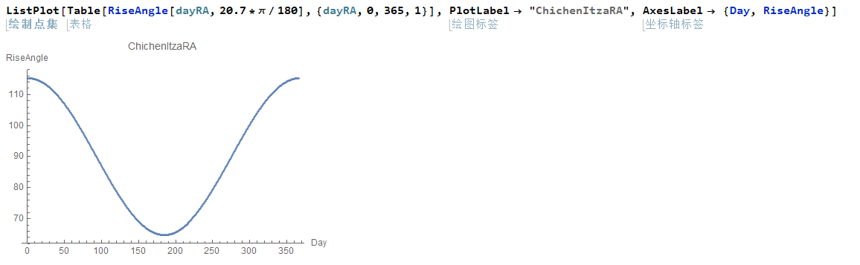

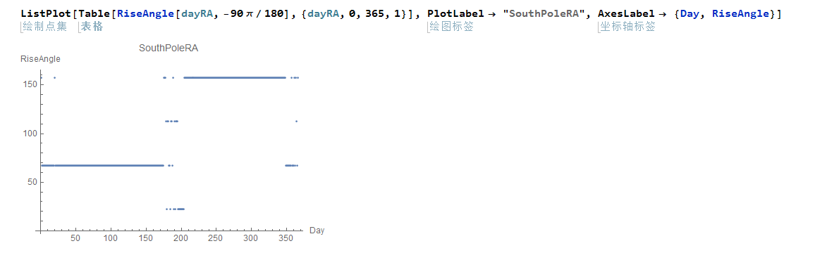

These two graphs show us the changing of rising angle of Chichen Itza and South Pole. The rising angle of Chichen Itza is very similar to Boulder, since the difference between latitude is not large. For the graph of South Pole, the graph looks strange because the is not sun rising and setting happen in this place.

The maximum of rise angle is 90°, which not happens on every place on earth. The maximum of rise angle will only happen around the equatorial, which is between latitude N 23.5° and S 23.5°. The maximum of rise angle will happen twice a year on these range of latitude around the equatorial. (Calculation on Mathematica).

The rise angle graph of three different latitude (Boulder, Chichen Itza, South Pole)

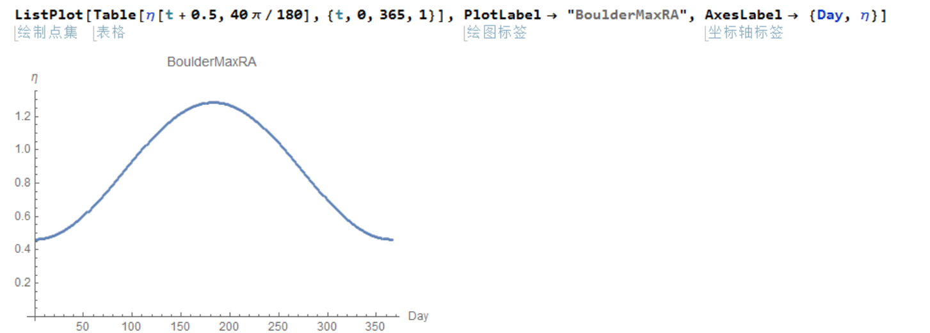

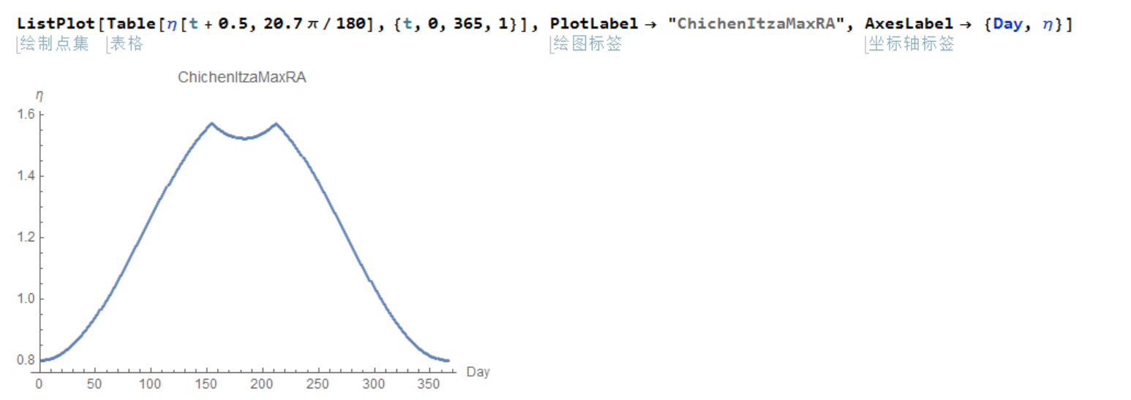

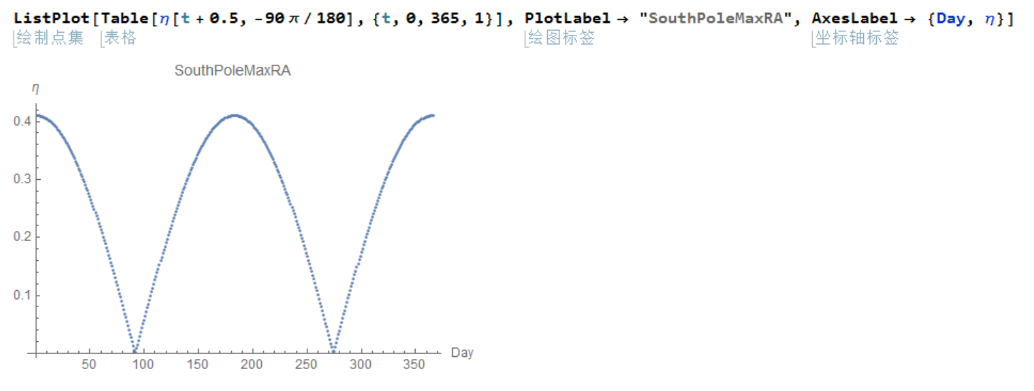

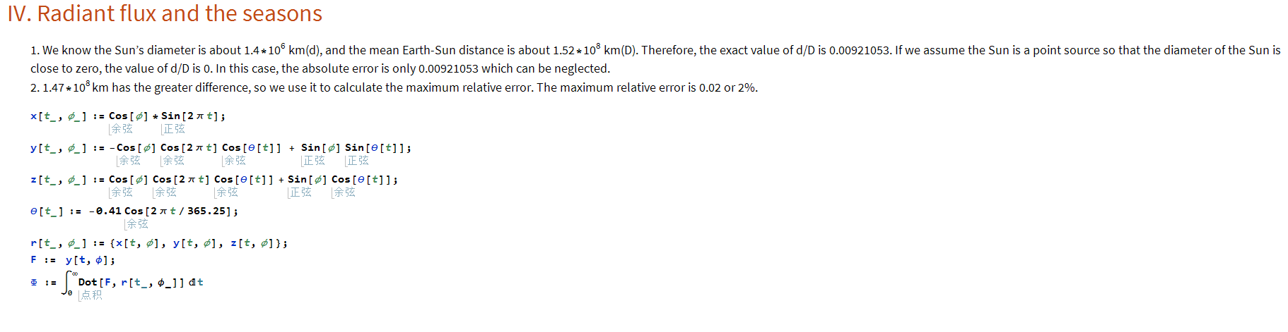**Answers for question V**

1. As shown in the graph below, the two days that happen zenith passage should be around t = 170 and t = 230.



2. By using this graph, we successfully predict the two dates. Mar 26 is about t = 170 and July 20 is about t = 230.

3. No, we are not able to see a zenith passage in Boulder, since the latitude of bolder is much higher than the range that we are able to see a zenith passage. There always be an angle that makes sun light cannot perpendicular to the ground in Boulder.

4. The are four faces and each face has 91 steps, those steps are used to observe the sun light and calculate the date. The total steps are 4 times 91 and add the top one, that just equals to 365 days.

5. The sunrise happen in the NE corner at May 24th and July 19th, when the sun just get the right above of the EL Castillo, it reaches the maximum height. Then the sun is going to set toward the SW corner.

**Conclusion**

According to our report, we used the given equations to find the relationship between day times and night times, we related this to the angle of incidence from sun light to test different situations happened on earth. Our Data shows many special days that sun light reflect on earth, which can be used to count time and even seasons. To compare with ancient timer EI Castillo, they all predict the time accurately.